I hereby authorize Maren Medical Group to disclose or receive the following information from the health records of the patient listed below:
Patient Name: | SSN:
Patient Phone Number: | Date of Birth:
Release Information To: | Receive Information From:
Organization/Person: | Organization/Person:
Address: | Address:
City/State/Zip: | City/State/Zip:
Phone:  Fax: | Phone:  Fax:
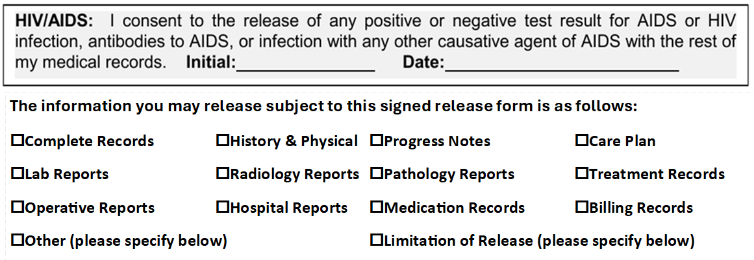
_______________________________________________________________________________________________
_______________________________________________________________________________________________
The purpose/reason for this release of information is as follows:
______________________________________________________________________________________________
______________________________________________________________________________________________
This authorization will automatically expire six months from the date of execution unless otherwise noted: ______________________________________________________________
I understand that signing this authorization is voluntary and that my treatment payment, enrollment in health plan, or eligibility for benefits will not be conditioned upon whether I sign this authorization
I understand that I have the right to revoke this authorization at any time by writing the releaser, except where uses or disclosures have already been made based upon my original permission.
I understand that information disclosed pursuant to this authorization could be re-disclosed by the recipient. Such disclosure is in some cases not protected by California law and may no longer be protected by federal confidentiality law (HIPAA). The recipient of this information is requested not to re-disclose this information without my authorization for disclosure. Maren Medical Group, its employees, officers and physicians, are hereby released from any legal responsibility or liability for improper re-disclosure of the above information to the extent indicated and authorized herein.
I will receive a copy of this authorization after I have signed it. A copy of the authorization is valid as the original.

________________________________________________
Signature of Patient or Legal Representative

________________________________________________ ________________________
Print Name Relationship

________________________________________________________________________________________________
Address/State/Zip (if other than patient)

________________________________________________ ________________________
Phone Number (if other than patient) Date Signed

_________________________________________________ ________________________
Signature of Witness Date

Clinical Use Only:
Authorization Received by: | Date:
Patient/Representative Identification: | Verified by:

